For the attention of Addingham Parish Council

Fitting repeater and aerial to the Addingham Hub.

Having enquired about the fitting of a ‘repeater’ in the Addingham Hub I make the formal proposal as follows;

That the aerial required for the repeater is as shown below and that this is fitted above the gutter on the gable end, close to the corner but not protruding above the roof. The bracket to be fitted as close as possible to the gutter in order to hide (as much as possible) the bracket from those observing from below. This will ensure the installation has minimal visual impact. The cable to follow the route of the existing BT cable which can be seen here below the guttering.

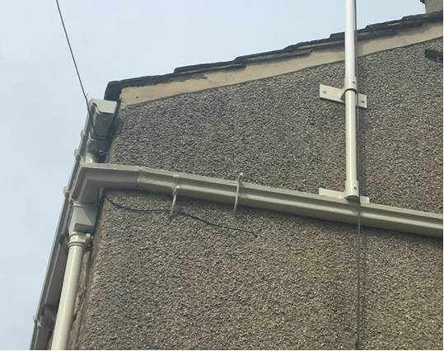

The repeater to be fitted to the ‘loft’ space next to the (parish council) ‘comms’ box.

The repeater requires connecting to the ‘comms’ box downstairs. All cables for this to be fitted into the existing trunking.

All work to be carried out under the supervision of Ninehundred Communications Group.

